Scenario: check windowhandles
Step: Launch "WindowHandlePage" WebPage - PASS
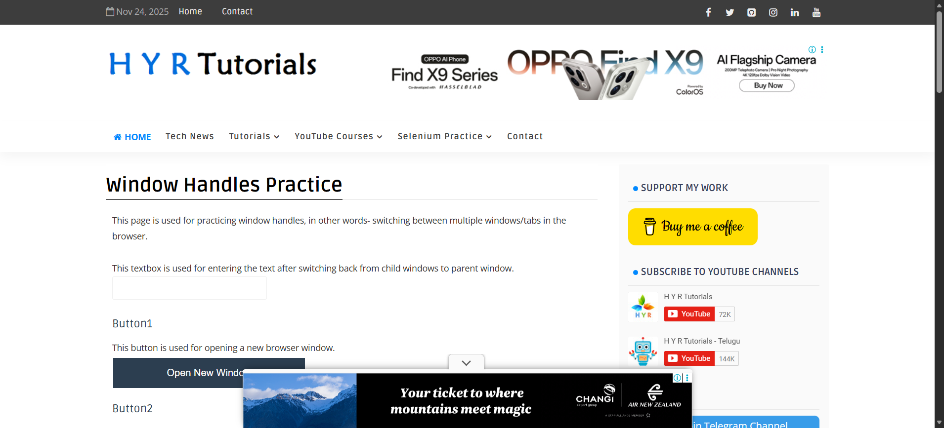
Step: User click the "Window_Button" element at "WHPage" page - PASS
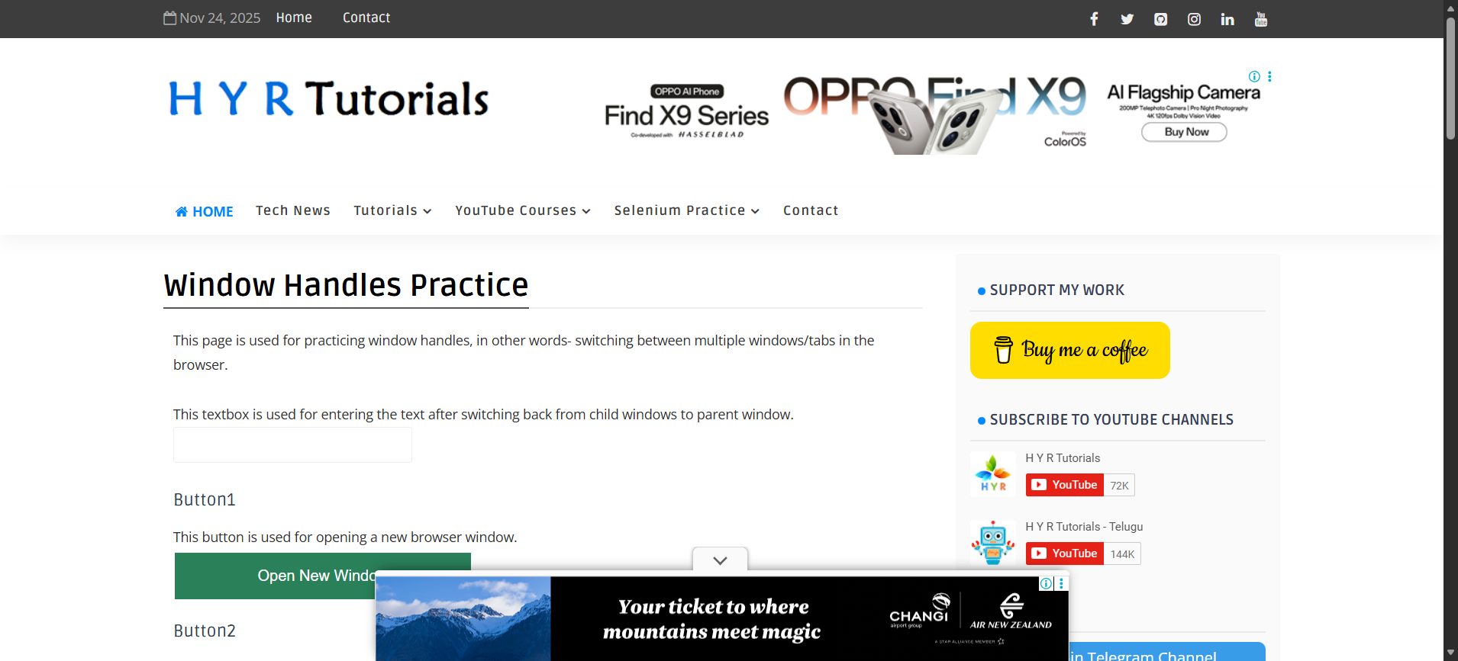
Step: And the user validate the page title with"Window Handles Practice - H Y R Tutorials" - PASS
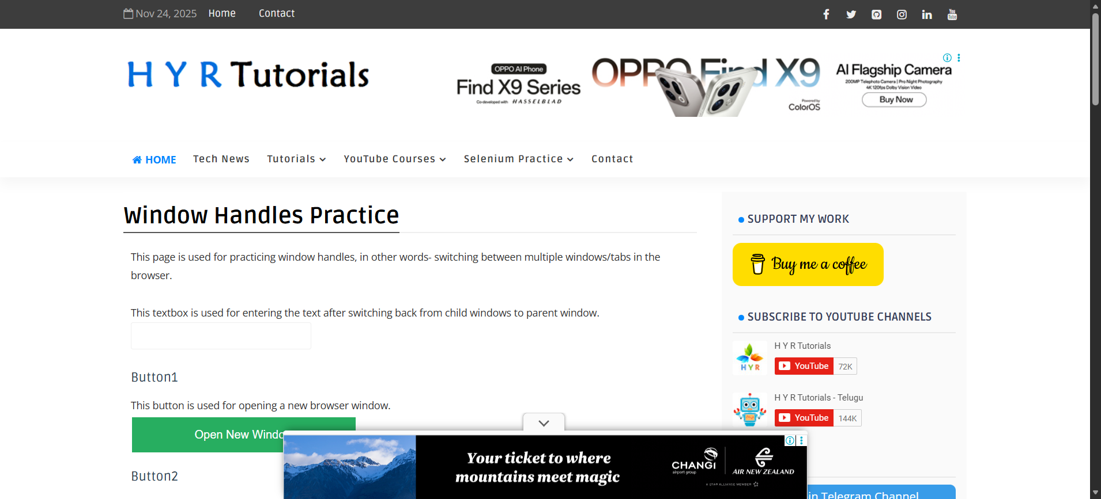
Step: And the user waits for "5" seconds - PASS
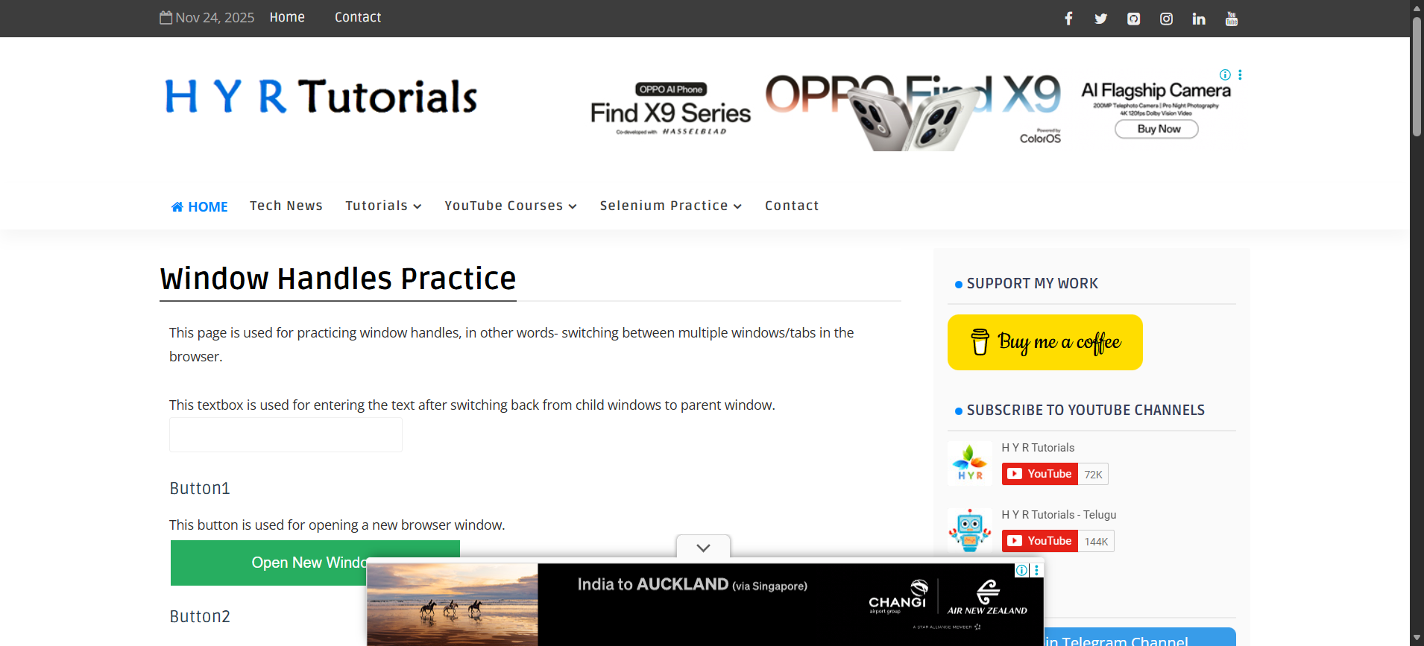
Step: Then the user switch to "firstWindow" - PASS
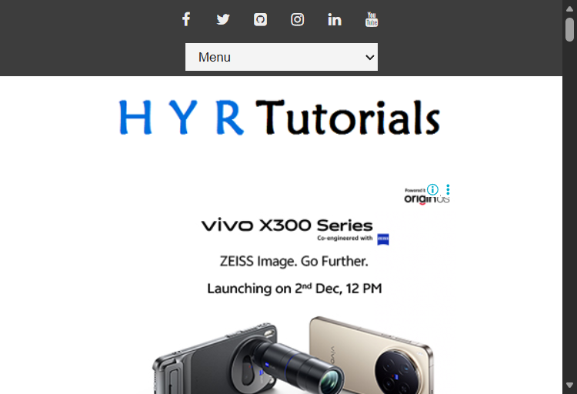
Step: And the user validate the page title with"Basic Controls - H Y R Tutorials" - PASS
Step: Then the user switch to "parentwindow" - FAIL
Execution Summary:
Total Steps: 7
Passed: 6
Failed: 1

